Oxford
A Visitor’s Guide

Contents
Getting around Oxford 3
Finding Oxford and how to get around town 3
Travel to Oxford from UK Airports 3
Airport buses 3
Travel around Oxford 3
Bus routes, travel card schemes whilst in Oxford 3
Public transport 4
Taxi numbers 5
Travel outside Oxford 5
Accommodation in Oxford 6
College Rooms
Shared House
Overseas Student Accommodation
Bed and Breakfast or Guest Houses 8
Leisure time 9
Young Professionals Oxford 9
Discount schemes 9
Bicycle hire shops
Places to visit 11
Local Attractions & Points of Interest
Cinemas 12
Gym 13
Places to eat and drink 14

Getting around Oxford
Finding Oxford and how to get around town
Travel to Oxford from UK Airports
Airport buses
Oxford Bus Company runs a service from both Heathrow and Gatwick airport.

From Heathrow the bus stops are at Terminal 5 and Heathrow Central Bus Station and the journey will take 80-90 minutes to Oxford.

From Gatwick there are bus stops at both the North and South terminals and the journey will take between 2 to 2 ½ hours.

Upon arrival in Oxford get off at the final stop which is Oxford Bus Station, this is in the centre of Oxford.

Please note the buses will only accept cash if you are buying a ticket on board. You can book your ticket online in advance.

Link to the Oxford Bus Company – The Airline www.airline.oxfordbus.co.uk

Travel around Oxford
Bus, travel card schemes in Oxford
The Oxford Key card for the SmartZone is a pre-pay bus travel card. It allows travel on any Oxford Bus Company, Stagecoach or Thames Travel bus within the SmartZone area, which covers the city centre and outer roads. Please see the links and bus route map below.
www.oxfordkey.co.uk/smart-card
www.oxfordkey.co.uk/smart-card/faq/key-product-guide/65
Public transport
From –
Banbury Road – Oxford Ctr Bus No: 2, 2A, 2B, 2C, 2D, 500
Woodstock Road – Oxford Ctr Bus No: 6, S3, 300
For additional information visit www.oxfordbus.co.uk
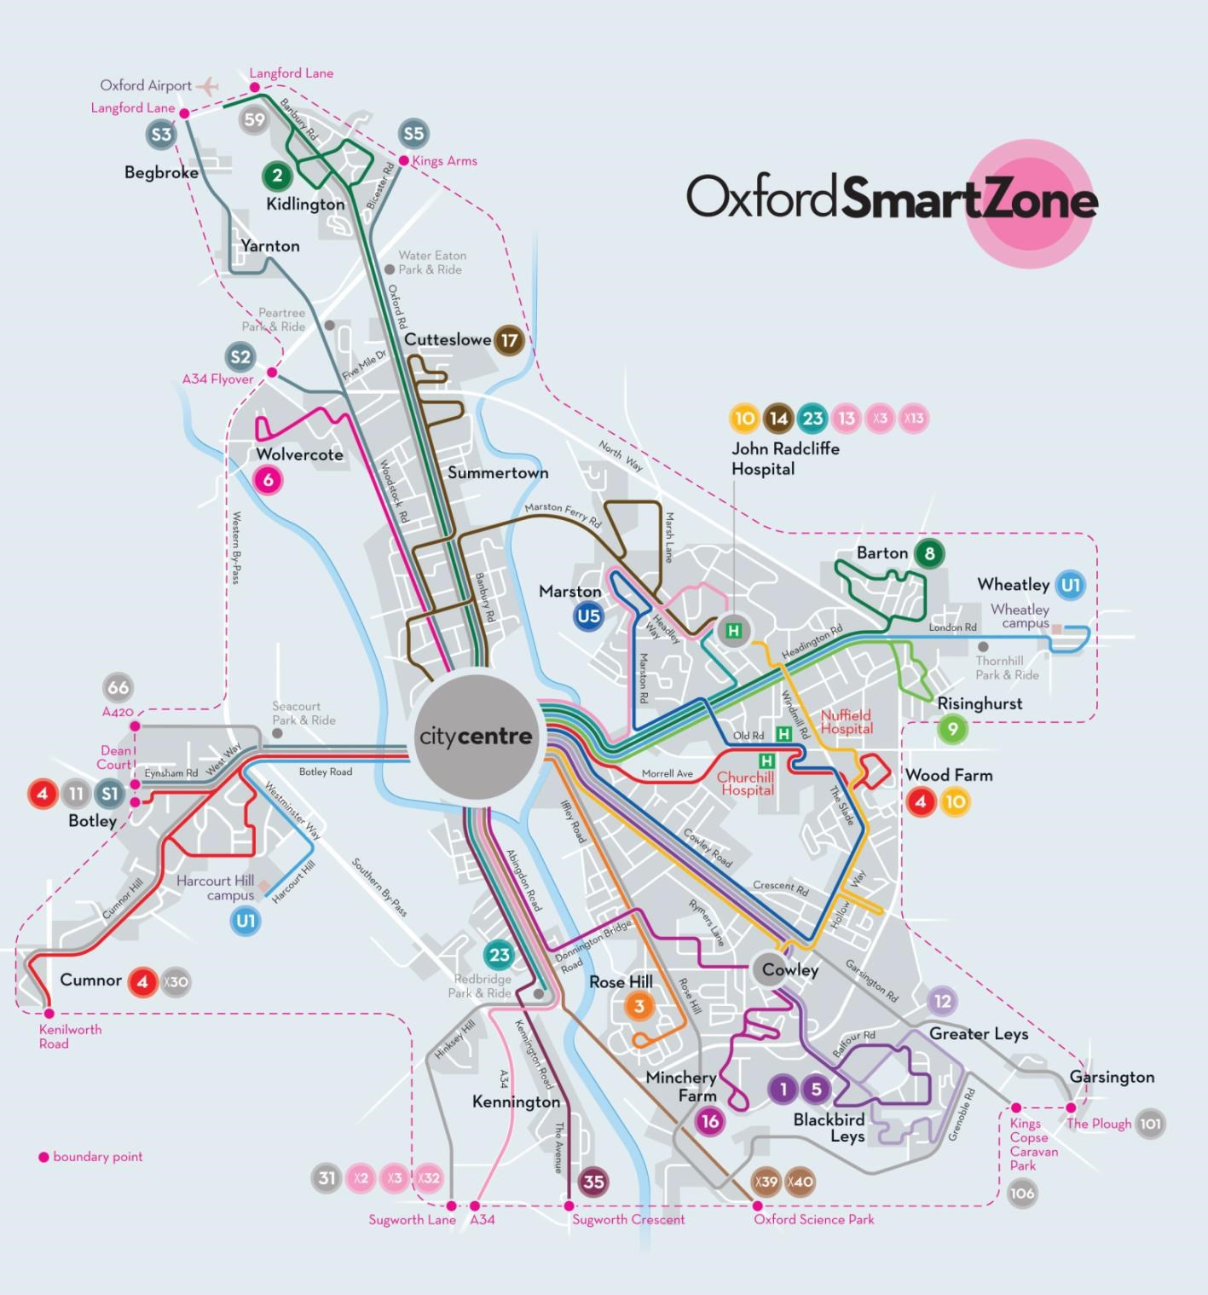

Warneford
Hospital

Taxi numbers
Most cabs have meters in the UK however if they do not, check they have a cab licence plate which will be on the back of the car and always agree the price before you take the cab.
The numbers below are taxi companies we use at the University so should be reliable.
Royal Cars www.royal-cars.com
+44 1865 777333
001 Taxis www.001taxis.com
+44 1865 240000
ABC Taxis
www.abcradiotaxis.co.uk
+44 1865 770077
Oxford City Cars www.oxfordcitycars.com
+44 1865 703030

Travel outside Oxford
Coach
www.nationalexpress.com/destinations
Train
www.networkrail.co.uk/timetables-and-travel

Accommodation in Oxford
Short Term
The University of Oxford is situated in numerous colleges and buildings throughout the city. Living/staying in Oxford should ensure being close to the University and student life. Graduate rooms are often quieter and, therefore, recommended for mature students or academic visitors.
There are various options you could consider for accommodation.
www.headington.org.uk/wheretostay www.airbnb.co.uk

College Rooms
Look on University Rooms
www.universityrooms.com/en/city/oxford/home
This website advertises rooms within the colleges. Rooms are however at a premium as they are allocated to each of the College’s students first during term time. College rooms can also sometimes offer an evening meal for a reasonable cost.

Longer Term

Shared House
Consider looking on SpareRoom.com www.spareroom.co.uk

Overseas Student Accommodation
www.comhouse.org/
Commonwealth House is located in the centre of Oxford near Christ Church College and has reasonable room rates.

North Oxford Overseas Centre provides accommodation for international post-graduate students, research workers and visiting scholars from all parts of the world. It is located slightly out of the town centre of Oxford, a 30 minute walk away or a short bus ride.
www.nooc.org.uk

Bed and Breakfast or Guest Houses

All Seasons Guest House | 63 Windmill Road,  Oxford, OX3 7BP  Tel: 01865 742215 | Email:  info@allseasonsguesthouse.com  www.allseasonsguesthouse.com
Claddagh Guest House | 112 The Slade,  Headington, Oxford, OX3 7DX  Tel: 01865 751641 | Email:  info@claddaghguesthouse.co.uk  www.claddaghguesthouse.co.uk
The Conifers Guest house | 116 The Slade,  Headington, Oxford, OX3 7DX  Tel: 01865 763055 | Email:  stay@conifersguesthouse.co.uk  www.conifersguesthouse.co.uk
The Dial House | 25 London Road,  Oxford, OX3 7RE  Tel: 01865 425100 | Email: dialhouse@ntlworld.com  www.dialhouseoxford.co.uk
Mulberry Guest House | 265 London Road,  Headington, Oxford,  OX3 9EH  Tel: 01865 767 114 | Email:  stay@mulberryguesthouse.co.uk  www.mulberryguesthouse.co.uk
Oxford Guest House | 228 London Rd,  Headington, Oxford  Tel: (0)1865 308833 | Email: oxfordguesthouse@gmail.com  www.theoxfordguesthouse.co.uk
Pickwick’s Guest House | 15-17 London Road,  Headington, Oxford, OX3 7SP  Tel: 01865 750487 | Email:  enquiries@pickwicksguesthouse.co.uk  www.pickwicksguesthouse.co.uk
Red Mullions Guest  House | 23 London Road,  Headington, Oxford,  OX3 7RE  Tel: 01865 742 741 | Email: stay@redmullions.co.uk  www.redmullions.co.uk
Remont Oxford Hotel | 367 Banbury Road,  Oxford, OX2 7PL  Tel: (0)1865 311020 | Email: info@remont-oxford.co.uk  www.remont-oxford.co.uk
Sandfield Guest House | 19 London Road,  Headington, Oxford,  OX3 7RE  Tel: 01865 767 767 | Email: stay@sandfieldguesthouse.com www.sandfieldguesthouse.com

Leisure time

Young Professionals Oxford
“Young Professionals Oxford aims to bring 20-30 year olds together for a chance to meet new people, socialise, play sports, enjoy trips and more on a regular basis. You may be new to the area with work or otherwise or you may just want to liven your social life up a little, either way this group aims to bring like-minded people together to socialise and have fun.
www.meetup.com/Young-Professionals-Oxford-socialising-sports-fun

Discount schemes
There are a number of discount schemes that you may find useful during your visit. They can offer deals with local restaurants, gyms, spas or shops. Log onto the websites and if you register, which is free, you will receive updates of the latest deals in Oxford.
Groupon www.groupon.co.uk
Amazon Local
www.local.amazon.co.uk/Oxford
Jack FM – The Jack Shop
www.jackfmoxfordshire.co.uk/jackaholics/vouchers

Bicycle hire shops
You will see a lot of people cycling in Oxford and lots of bicycles parked everywhere! You may like to cycle yourself whilst you are here and you can hire bicycles either for a day or two or for the length of your stay. Below are links to different hire shops.
Walton Street Cycles – 78 Walton street OX2 6EA www.baintonbikes.com/BikeHireLongHire.html or www.waltonstreetcycles.org.uk/Hire.html
The Cycle Centre – 85 Walton Street OX2 6EA – www.thecyclecentre.com/hire-bikes
OxonBike bike hire scheme
OXONBIKE is a self-service bike hire scheme for getting around quickly and cheaply. You can hire and return bikes at any OXONBIKE docking station.
Contact scheme customer services: 01865 238013 Email: oxford@hourbike.com www.oxonbikes.co.uk

Places to visit

Visit Oxfordshire – Link to a website with ‘What’s On’ and information on discounted tickets and tours. www.visitoxfordandoxfordshire.com/travel-information/Tourist-
Information.aspx
Further useful websites for information on staying in Oxford and a “what’s on” guide www.experienceoxfordshire.org www.oxfordcity.co.uk
www.universityrooms.com/en/city/oxford/home www.oxfordcityguide.com/ee2/index.php?/TouristInfo www.dailyinfo.co.uk
Local Attractions & Points of Interest
Ashmolean Museum – The world’s first university museum.
www.ashmolean.org
Blenheim Palace – Birthplace of Sir Winston Churchill. A historic house with beautiful gardens, water cascades, tea room and restaurant; located just outside Oxford in Woodstock. Events such as horse trials and jousting are often held here.
www.blenheimpalace.com
www.blenheimpalace.com/whats-on/events
Bus from Oxford to Woodstock
The S3 bus service to Woodstock runs every 30 minutes from Oxford to the gates of Blenheim Palace.
Buy your tickets to the Palace aboard the bus and you can receive a special discount. Ask the driver for more details, or check the S3 leaflets on board.
SAVE 30% on your visit by booking with Stage Coach
For the timetable and more information on the route, visit www.stagecoachbus.com
Bodleian Library - the largest university library in the UK holding over nine million printed items. www.bodleian.ox.ac.uk
Botanic Gardens - the oldest botanic garden in Great Britain. www.botanicgarden.ox.ac.uk
Christchurch College – Famous for Tom Tower and the Christchurch Cathedral. In the film Harry Potter and inspired Lewis Carroll when writing Alice in Wonderland.
www.chch.ox.ac.uk/visiting
Creation Theatre – Perform Shakespeare plays often outdoors in the grounds of the colleges. See link below. www.creationtheatre.co.uk

New College – Choir for Evensong in the College Chapel. This is sung on each day at 6.15pm except Wednesday and Thursday. Sunday is at 6.00pm. See link below for further details. www.newcollegechoir.com/choral-services.html
Port meadow – Good place to go walking.
www.oxford.gov.uk/PageRender/decLP/PortMeadow.htm
University of Oxford Colleges - Oxford University is a unique and historic institution. There are 38 colleges; perhaps the most famous is Christ Church whose Great Hall inspired Hogwarts Hall in the Harry Potter movies. www.ox.ac.uk/colleges/index.html
University Parks - 70 acres of parkland on the West bank of the River Cherwell. The Parks include sports areas and a large collection of plants and trees in landscaped surroundings. www.parks.ox.ac.uk

Cinemas
Odeon, George Street, 0871 2244007, www.odeon.co.uk
Odeon, Magdalen Street, 0871 2244007, www.odeon.co.uk
Phoenix Picture House, 57 Walton Street, 01865 512526, www.picturehouses.co.uk

Gym
Oxford University Sport
This is where Roger Bannister broke the four-minute mile in 1954 and still has the running track, gym, classes and swimming pool which members of the University and the general public can use. The gym requires an annual membership; however the aerobic classes are open to non-members.
www.sport.ox.ac.uk/membership/classes

Ferry Leisure Centre – Fusion
Ferry Pool Rd, Oxford OX2 7DP; +44 844 893 3222
Large modern multi-purpose centre, located in Summertown, to the north of Oxford city centre.
www.fusion-lifestyle.com/centres/Ferry_Leisure_Centre

Yoga Studios
Wild Honey a peaceful, quiet little room in the back of a lovely organic health shop.
www.wildhoneylove.com
Yoga Venue is a bigger and busier environment with many classes.
www.yogavenue.co.uk

Places to eat and drink
Venue Details Address and links

Traditional afternoon tea

The Old Parsonage  Traditional English pubs | This is the best place to go for a traditional afternoon tea experience. You will however need to book and it is slightly on the pricey side but great as a treat!
Turf Tavern | 13th century Ale House. It is hidden down some narrow pathways in the centre of Oxford. Great place to visit.
Eagle and Child | Where J.R.R. Tolkein and C.S. Lewis met fellow writers. Stocks real ales and has traditional pub food.
The Perch | Good to walk to from Port Meadow.
The Rose & Crown | Small traditional English pub. Very good food and traditional beers
Kings Arms | Popular pub. Good food.
Jude the Obscure | All-day food and real ales in traditional, red-brick pub.

1 Banbury Road, OX2 6NN www.oldparsonage-hotel.co.uk/menus/afternoontea
4-5 Bath Place OX1 3SU www.theturftavern.co.uk
49 St Giles, Oxford, OX1 3LU www.nicholsonspubs.co.uk/theeagleandchildoxford
Binsey Lane, Oxford, OX2 0NG
Tel 01865 728891 www.the-perch.co.uk

North Parade, Oxford OX2 6LX
Tel 01865 510551 www.roseandcrownoxford.com
40 Holywell Street, Oxford, OX1 3SP
Tel 01865 242369 www.kingsarmsoxford.com

54 Walton St, Oxford OX2 6AE Tel 01865 557309
www.judetheobscure-oxford.co.uk
Freud | The stained glass remains in this stone church, now a cocktail bar with a European menu. | 119 Walton St, Oxford OX2 6AH  Tel 020 7240 1100 www.freud.eu/cafe-bars
The Half Moon | Small Irish pub offering live gigs by jazz and folk bands, serving real ales on tap. | Address: 17 St Clement's St, Oxford OX4 1AB  Tel 01865 247808
Café Tarifa | Cafe/bar with leather sofas and terrace garden, plus a blackboard menu and cocktails. | 56-60 Cowley Road, Oxford OX4 1JB  Tel 01865 256091 www.cafe-tarifa.co.uk

Edamame | Japanese Menu | 15 Holywell Street, OX1 3SA  Tel 01865 246916 www.edamame.co.uk
Sojo | Chinese – Szechuan, Shanghainese & Cantonese | 6-9 Hythe Bridge Street , Oxford OX1 2EW  Tel 01865 202888 www.sojooxford.co.uk
Quod Brasserie | All day brasserie also serving afternoon tea. | 92-94 High St, Oxford OX1 4BN  Tel 01865 202505 www.quod.co.uk
Ashmolean Dining Room | European food on the rooftop of Oxford’s Ashmolean  Museum. Not cheap but good food and great surroundings | Ashmolean Museum, Beaumont Street, Oxford OX1 2PH Tel 01865 553823 www.ashmolean.museum/eating
The Cherwell Boathouse | You will need to book a table. European food. | Bardwell Road, Oxford OX2 6ST  Tel 01865 552746 www.cherwellboathouse.co.uk
Door 74 | Freshly cooked food with a range of dishes, any time of day. | 74 Cowley Road, Oxford OX4 1JB  Tel 01865 203374 www.door74.co.uk/Menus.html
Chang Mai Kitchen | Thai food in a restaurant which is tucked away down an alleyway. It is in a 3 storey timber framed building which dates back to the 1630’s | 130a High Street Oxford  Tel 01865 202233 www.chiangmaikitchen.co.uk
Varsity Club | A place to drink and eat with amazing roof top where you can sit and see the spires Oxford. | 9 High Street Oxford  Tel 01865 248777 www.tvcoxford.co.uk
Browns Restaurant | Modern British food with a contemporary twist | 5-11 Woodstock Road Tel 01865 511995  www.browns-restaurants.co.uk/oxford

Al-Andalus Tapas Bar | Spanish menu | 10 Little Clarendon St, City Centre, Oxford OX1 2HP  Tel 01865 516688 www.tapasoxford.co.uk
St Giles’ Café | Upmarket cafe with classy breakfasts, light lunches and afternoon tea. | 52 St Giles, Oxford OX1 3LU  Tel 01865 554200 www.stgilescafe.com
Taylors Deli | Specialise in gourmet sandwiches, lunches. | 31 St Giles, Oxford OX1 3LD  Tel 01865 558853 www.taylorsoxford.co.uk
The Handle Bar | Casual cafe with whitewashed bricks and cycling artefacts, for artisan coffee, breakfast and snacks. | Bike Zone 26-32 St Michaels Street, Oxford OX1 2EB Tel 07964 241212
Jacobs Inn | Cosy wood-beamed gastropub with a decked beer garden and a menu of updated pub grub. | 130 Godstow Rd, Oxford OX2 8PG  Tel 01865 514333 www.jacobs-inn.com
Kazbar Restaurant | Spanish/Moroccan tapas dishes | 25-27 Cowley Rd, Oxford OX4 1HP  Tel 01865 202920 www.kazbar.co.uk
Taberu | Traditional Japanese restaurant for sushi, noodles and bento | 100 Cowley Rd, Oxford OX4 1JE  Tel 01865 434100 www.taberu.co.uk
Branca | Italian menu | 111 Walton St, Oxford OX2 6AJ  Tel 01865 556111 www.branca.co.uk
Giraffe | International chain | 71 George St, Oxford OX1 2BQ  Tel 01865 201030 www.giraffe.net

61 Banbury Rd, Oxford OX2 6PE
Tel 01865 553540

The Standard Indian menu

117 Walton St, Oxford OX2 6AJ
Tel 01865 553557 www.standardoxford.com

oxfordmindfulness.org

